**Implementing Web Application**

**Create UI To Interact With Web Application**

|  |  |
| --- | --- |
| Team ID | PNT2022TMID36311 |
| Project Name | Nutrition Assistant Application |

**User interface To Interact with Web Application:**

Login Page for already Existing Users :

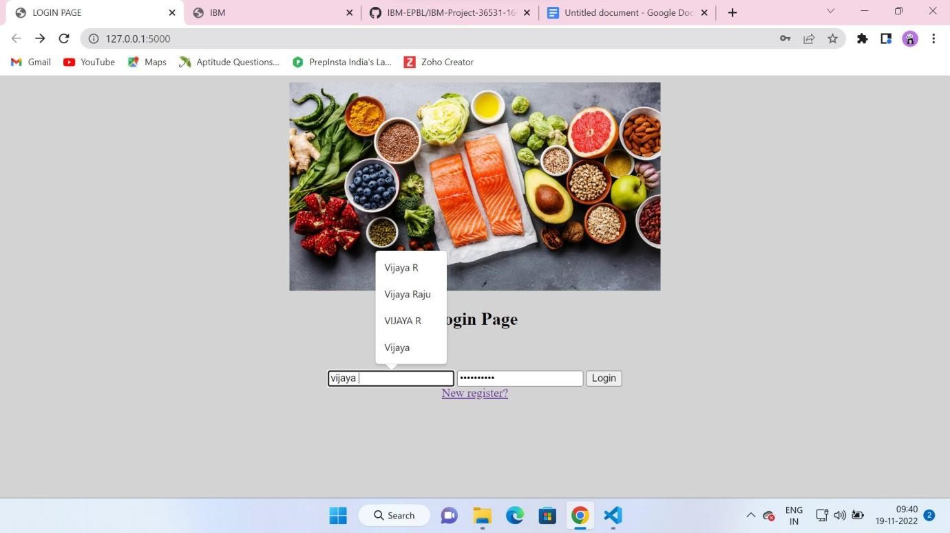

**Registration Page:**

Registration Page for New Users :

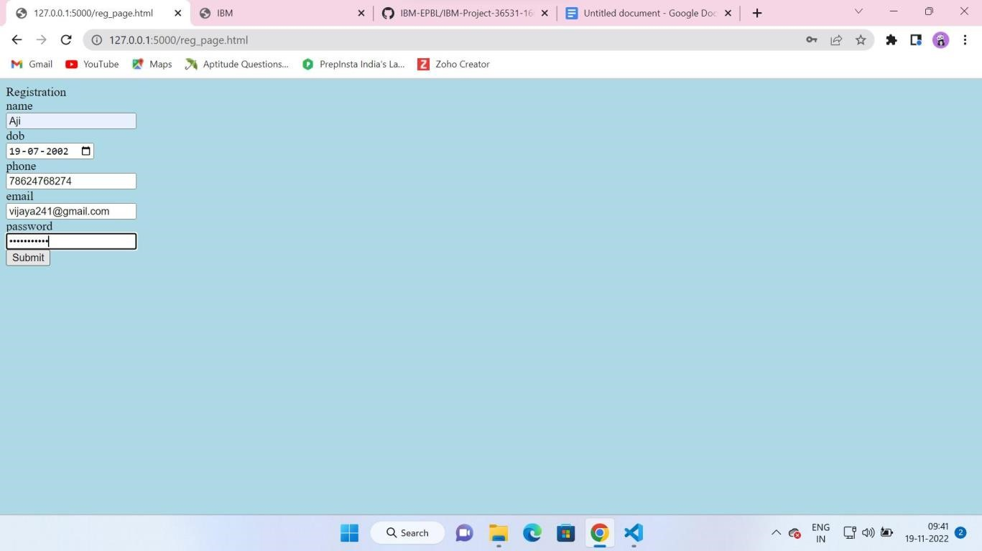

**User Interface:**

User Interface Page to see about the BMI Calculations and Uploading Image :

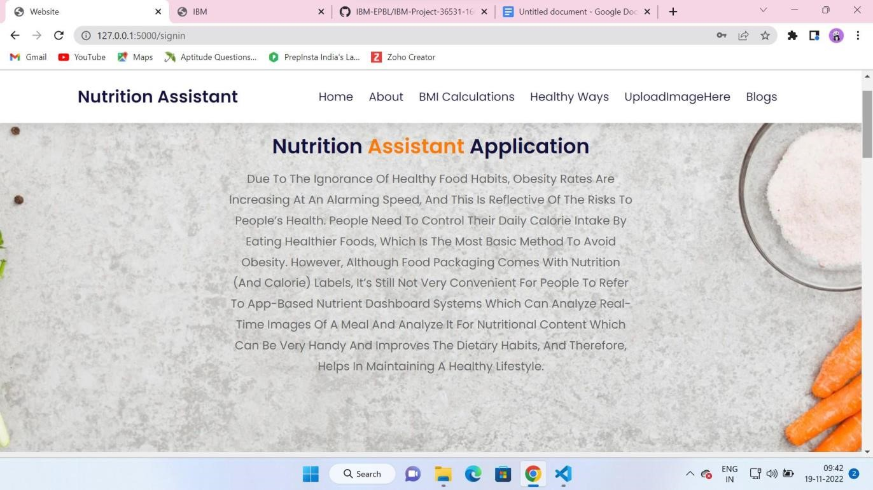

**Coding Phase:** sign_in.html

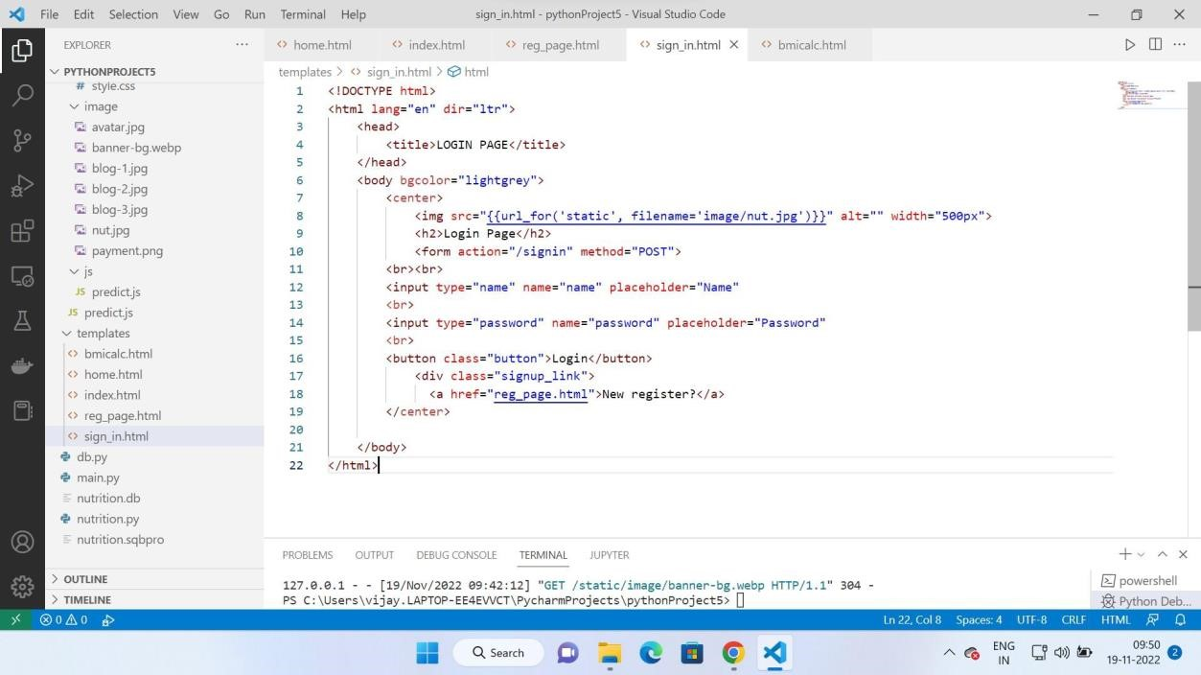

reg_page.html

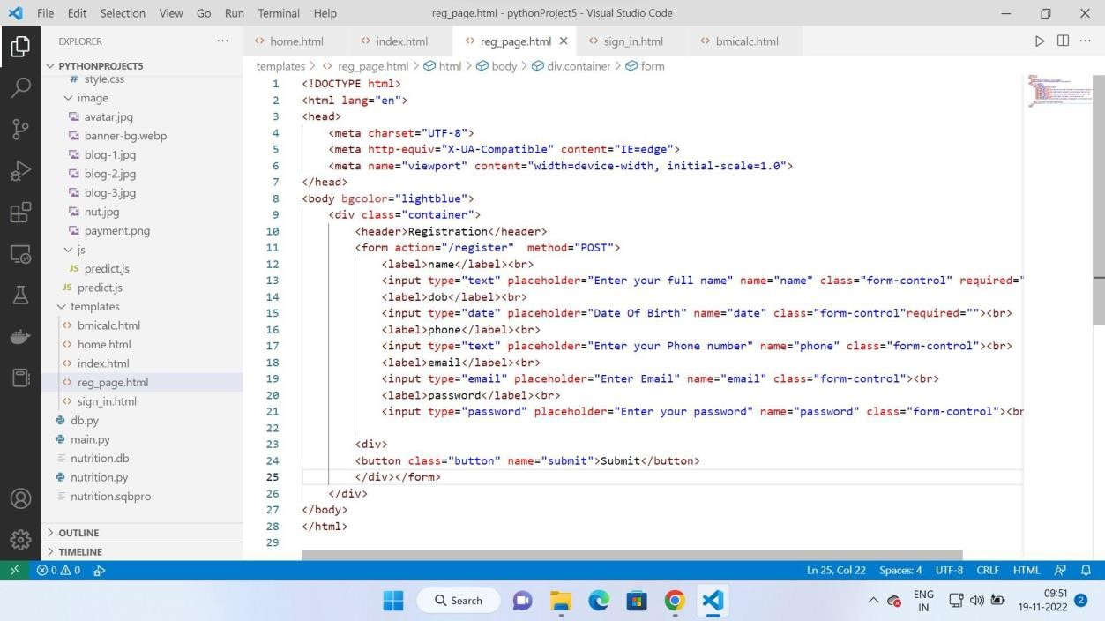

home.html

